# Apply filters to SQL queries

## Project description

In order to ensure my organization’s system is more secure it is my job to ensure the system is safe. To do this I will investigate all potential security issues and update employee computers as needed. The following steps provide examples of how I used SQL with filters to perform security-related tasks.

## Retrieve after hours failed login attempts

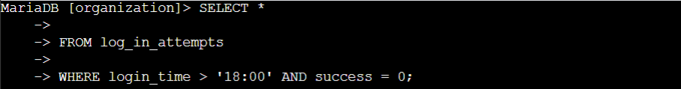

I started by selecting all data from the log_in_attempts table. I then used a WHERE clause with an AND operator to filter my results to output only login attempts that occurred after 18:00 and were unsuccessful.

The first condition is login_time > '18:00', which filters for the login attempts that occurred after 18:00. The second condition is success = FALSE, which filters for the failed login attempts.

## Retrieve login attempts on specific dates

A suspicious event occurred on 2022-05-09. Any login activity that happened on 2022-05-09 or on the day before needs to be investigated.

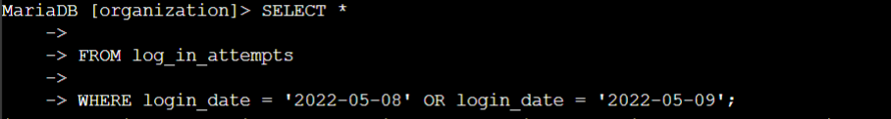

I started by selecting all data from the log_in_attempts table. I used a WHERE clause with an OR operator to filter my results to output only login attempts that occurred on either 2022-05-09 or 2022-05-08.

The first condition is login_date = '2022-05-09', which filters for logins on 2022-05-09. The second condition is login_date = '2022-05-08', which filters for logins on 2022-05-08.

## Retrieve login attempts outside of Mexico

I believe there is an issue with the login attempts that occurred outside of Mexico. These login attempts should be investigated.

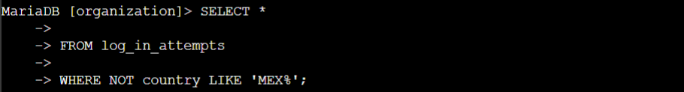

I started by selecting all data from the log_in_attempts table. I used a WHERE clause with NOT to filter for countries other than Mexico.

## Retrieve employees in Marketing

My team wants to update the computers for certain employees in the Marketing department. For this, I have to get information on which employee machines to update.

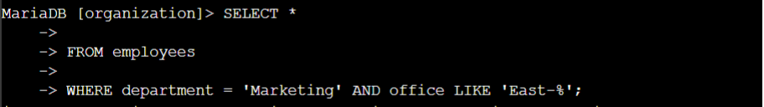

I started by selecting all data from the employees table. Then, I used a WHERE clause with AND to filter for employees who work in the Marketing department and in the East building.

The first condition is the department = 'Marketing' , which filters for employees in the Marketing department. The second condition is the office LIKE 'East%' , which filters for employees in the East building.

## Retrieve employees in Finance or Sales

The machines for employees in the Finance and Sales departments also need to be updated.

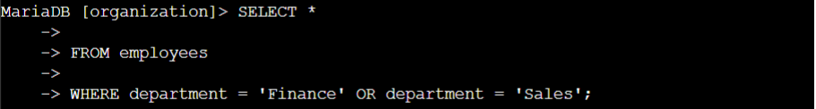

I started by selecting all data from the employees table. I used a WHERE clause with OR to filter for employees who are in the Finance and Sales departments.

## Retrieve all employees not in IT

My team needs to make one more security update on employees who are not in the Information Technology department.

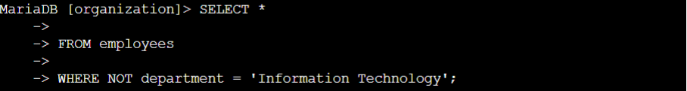

I started by selecting all data from the employees table. I used a WHERE clause with NOT to filter for employees not in this department.

## Summary

I applied filters to SQL queries to retrieve specific information on login attempts and employee machines using two different tables: log_in_attempts and employees. To refine the data, I utilized the AND, OR, and NOT operators, ensuring precise filtering for each task. Additionally, I employed the LIKEoperator along with the (%) wildcard to search for specific patterns within the data.